CSA1708-ARTIFICIAL INTELLIGENCE
LAB EXPERIMENTS

Program 1: Python program to solve 8.Puzzle Problem.
Aim:
To write a Python program to solve the 8-Puzzle problem using the Breadth-First Search (BFS) algorithm and find the sequence of moves from the initial state to the goal state.
Algorithm:
- Start the program.
- Enter the initial and goal states.
- Use BFS with a queue to store puzzle states.
- Find the blank space (0) and generate possible moves.
- Add unvisited states to the queue.
- Repeat until the goal state is reached.
- Display the solution path and number of moves.
- Stop.
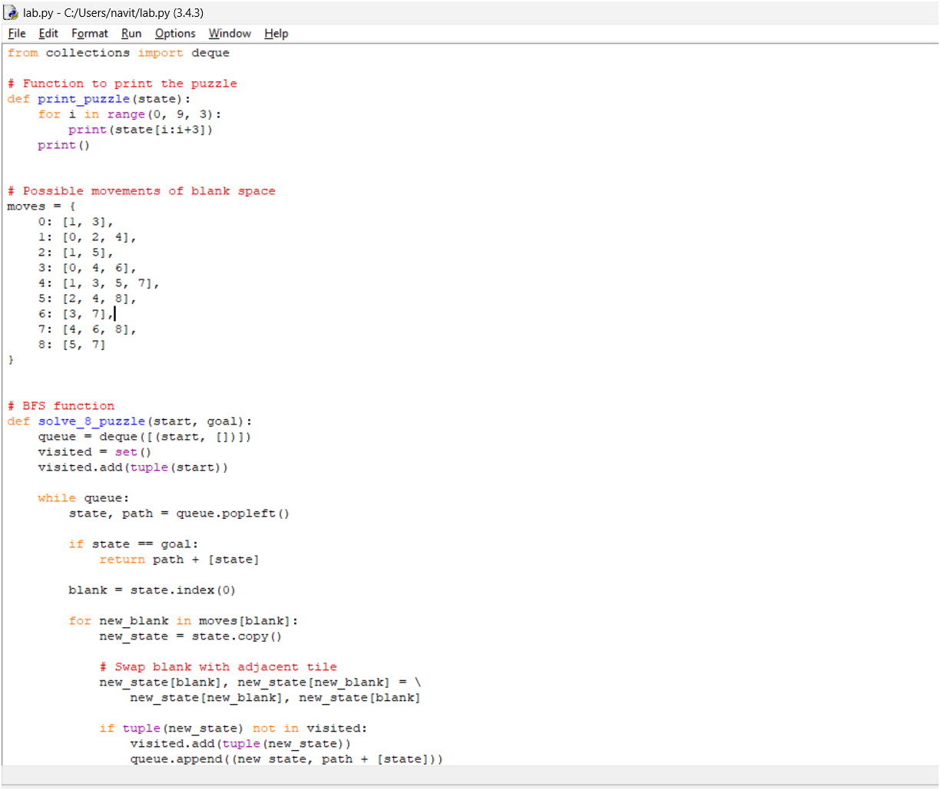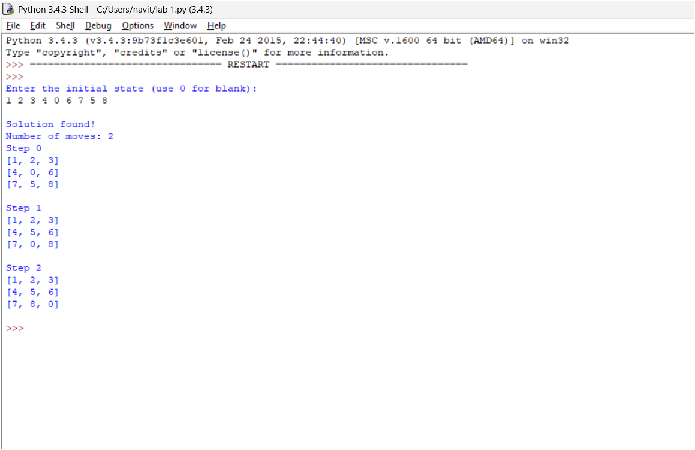
Result:
Thus, the 8-Puzzle problem was successfully solved using BFS in Python, and the solution path was obtained.

